**JAVA 1 ASSIGNMENT**

**RAGHAV GUPTA - 4099**

**----------------------------------------------------------------------**

**Q1. Write a program to replace a substring inside a string with another string ?**

**public class** Replace{

**public static void** main(String []args){

String s = **"the sun rises in the east"**;

System.***out***.println(**"original string - "** + s);

System.***out***.println(**"modified string - "** + s.replaceAll(**"the"**, **"new"**));

}

}

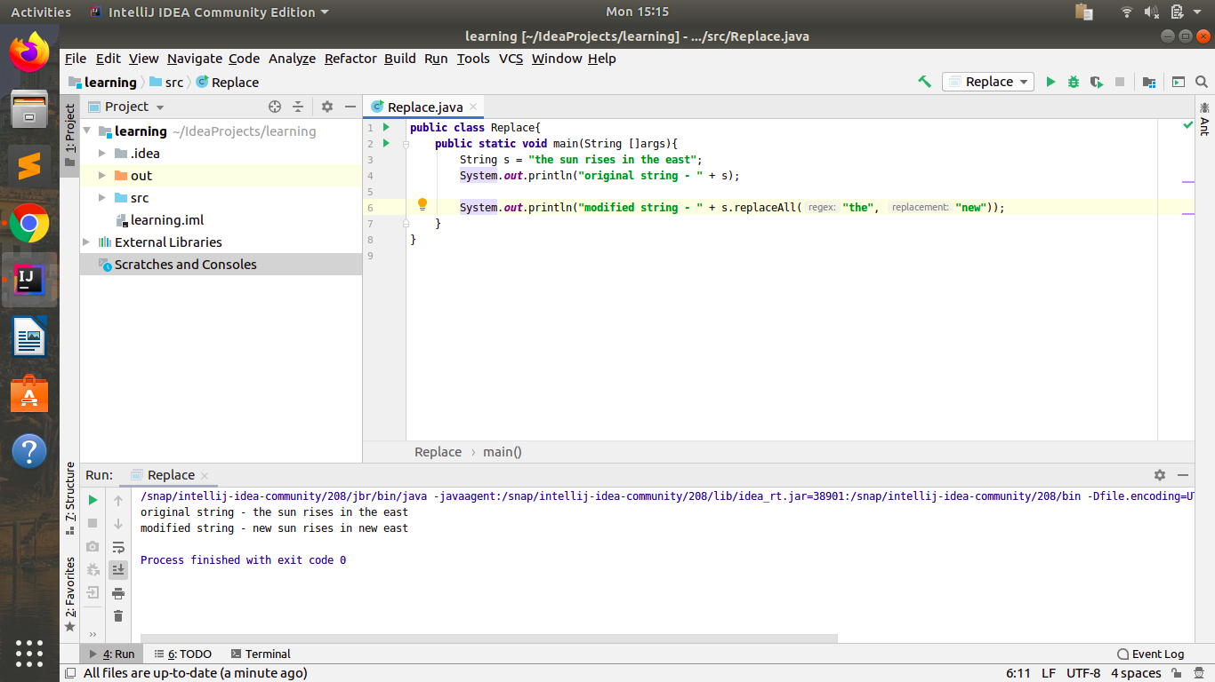

**Q2. Write a program to find the number of occurrences of the duplicate words in a string and print them ?**

**public class** Wordcount {

**public static void** main(String []args) {

String s = **"the sun rises in the east The Sun is round Sun is bright east yellow in color it is yellow"**;

s = s.toLowerCase();

String words[] = s.split(**" "**);

*// for(int i=0; i<words.length; i++){*

*// System.out.println(words[i]);*

*// }*

**for**(**int** i = 0; i < words.**length**; i++){

**if** (!words[i].equals(**""**)) {

**int** count = 1;

**for** (**int** j = i+1; j < words.**length**; j++) {

**if** (words[j].equals(words[i])) {

count++;

words[j]=**"0"**;

}

}

**if** (count > 1 && words[i]!=**"0"**) {

System.***out***.println(words[i] + **" "** + count);

words[i] = **""**;

}

}

}

}

}

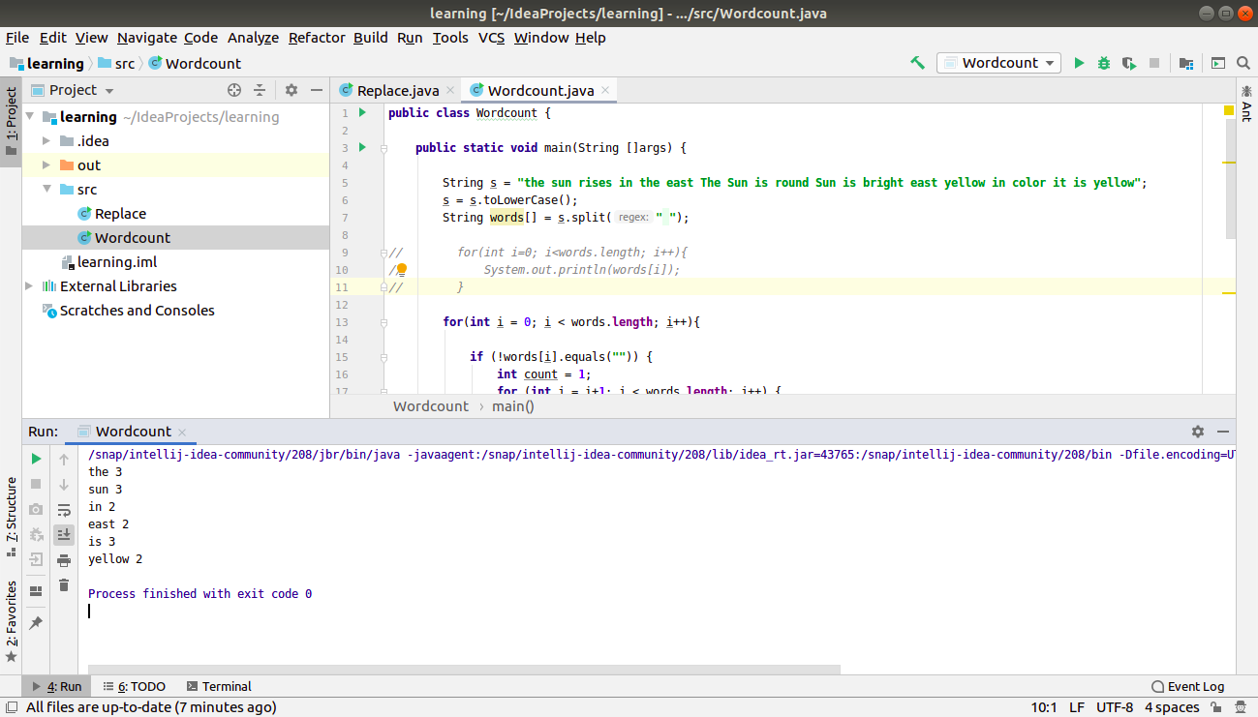

**Q3. Write a program to find the number of occurrences of a character in a string without using loop?**

**public class** Charcount {

**public static void** main(String args[]){

String s = **"raghavGupta"**;

*// System.out.println(s.replace("a", ""));*

**int** ans = s.length() - s.replace(**"a"**, **""**).length();

System.***out***.println(ans);

}

}

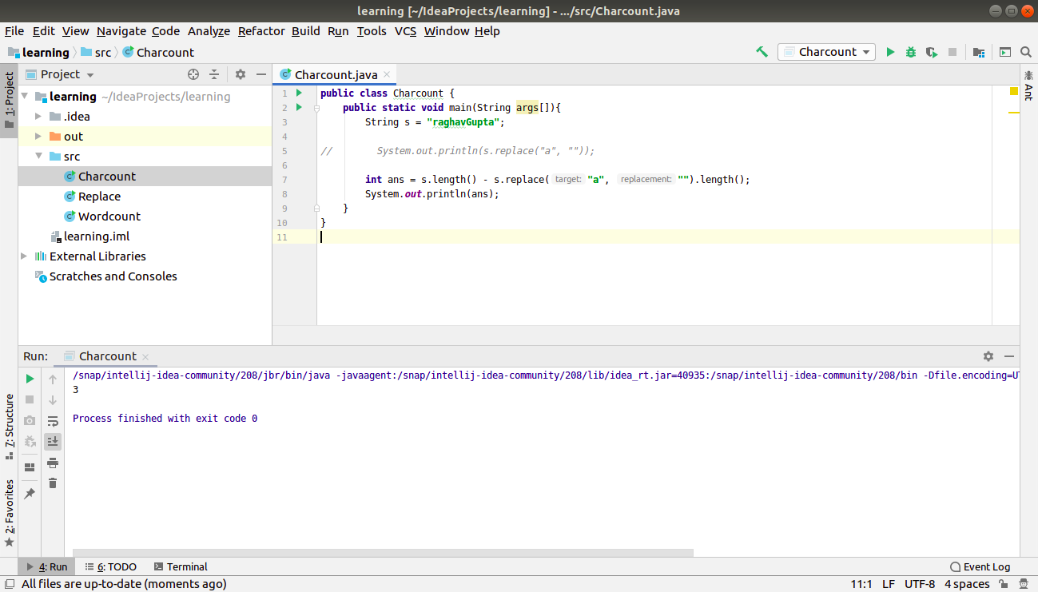

**Q4. Calculate the number & Percentage Of Lowercase Letters,Uppercase Letters, Digits And Other Special Characters In A String**

**public class** PercentageChar {

**public static void** main(String args[]){

String s = **"Raghav is a GOOD employee oof TTn. 5star h0te1. r@gh@v !$5000s0000"**;

**int** up=0, lo=0, ot=0, num=0;

**for**(**int** i=0; i<s.length(); i++){

**int** ascii = (**int**)s.charAt(i);

**if**(ascii>=65 && ascii<=90)

up++;

**else if**(ascii>=97 && ascii<=122)

lo++;

**else if**(ascii>=48 && ascii<=57)

num++;

**else**

ot++;

}

**int** l = s.length();

System.***out***.println(l);

System.***out***.println(**"lowercase - "** + lo + **" - "** + ((**double**)lo/l)*100 +**"%"**);

System.***out***.println(**"uppercase - "** + up + **" - "** + ((**double**)up*100/l)*100 +**"%"**);

System.***out***.println(**"number - "** + num + **" - "** + ((**double**)num*100/l)*100 +**"%"**);

System.***out***.println(**"other characters - "** + ot + **" - "** + ((**double**)ot*100/l)*100 +**"%"**);

}

}

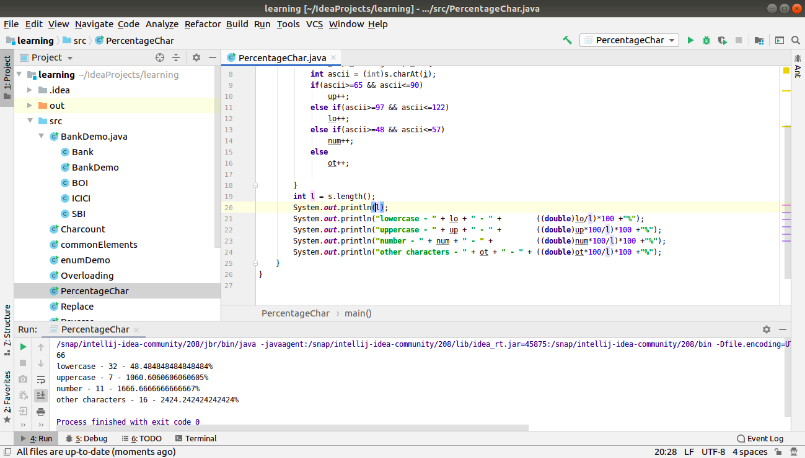

**Q5. Find common elements between two arrays.**

**public class** commonElements{

**public static void** main(String args[]){

**int** a[]= {1,2,3,4,5,6,7,8,6,10};

**int** b[]= {2,4,6,4,10};

*// to count the frequency of elements in array.*

*// basically i wish to use hashmap here but that’s out of agenda.*

**int** freq[] = **new int**[100000];

*// count the frequency of all elements from array 1*

**for**(**int** i=0; i<a.**length**; i++){

freq[a[i]]++;

}

*// if corresponding element is also present in array2, then print it.*

**for**(**int** j=0; j<b.**length**; j++){

**if**(freq[b[j]] > 0){

System.***out***.println(b[j]);

freq[b[j]]--;

}

}

}

}

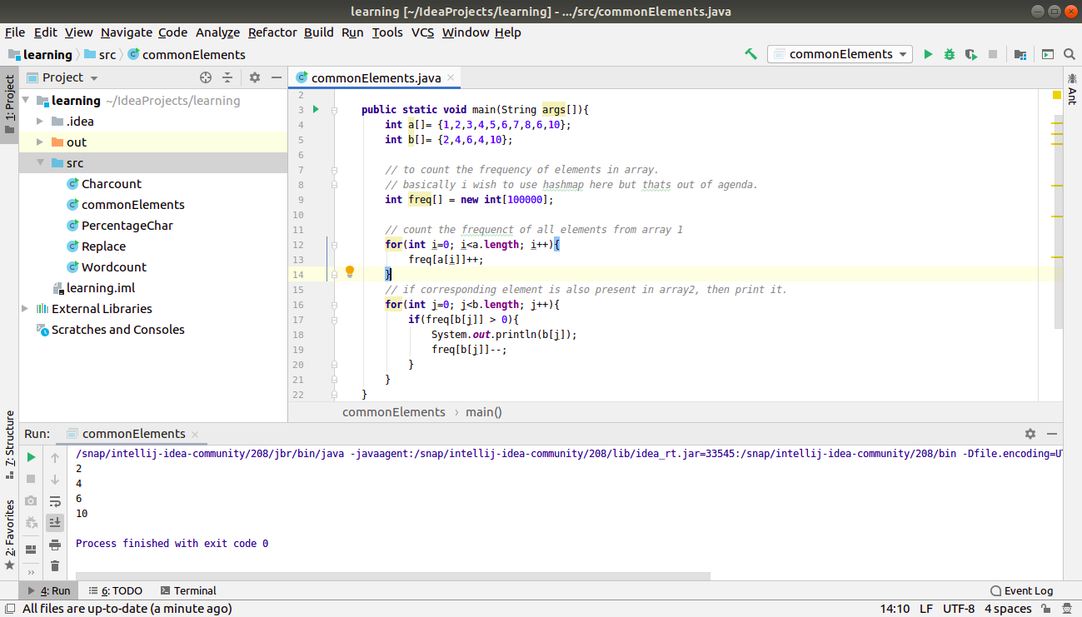

**Q6. There is an array with every element repeated twice except one. Find that element**

**public class** UniqueElement {

**public static void** main(String[] args) {

**int** arr[] = {1,2,3,4,3,2,1,4,5};

*// its a technique that xor of 2 same numbers is always 0*

*// and xor of a number with 0 is always the number itself*

*/// so, if we xor all the elements in the array, we get the unique element, IN THIS CASE*

**int** ans = 0;

**for**(**int** i=0; i<arr.**length**; i++){

ans = ans^arr[i];

}

System.***out***.println(ans);

}

}

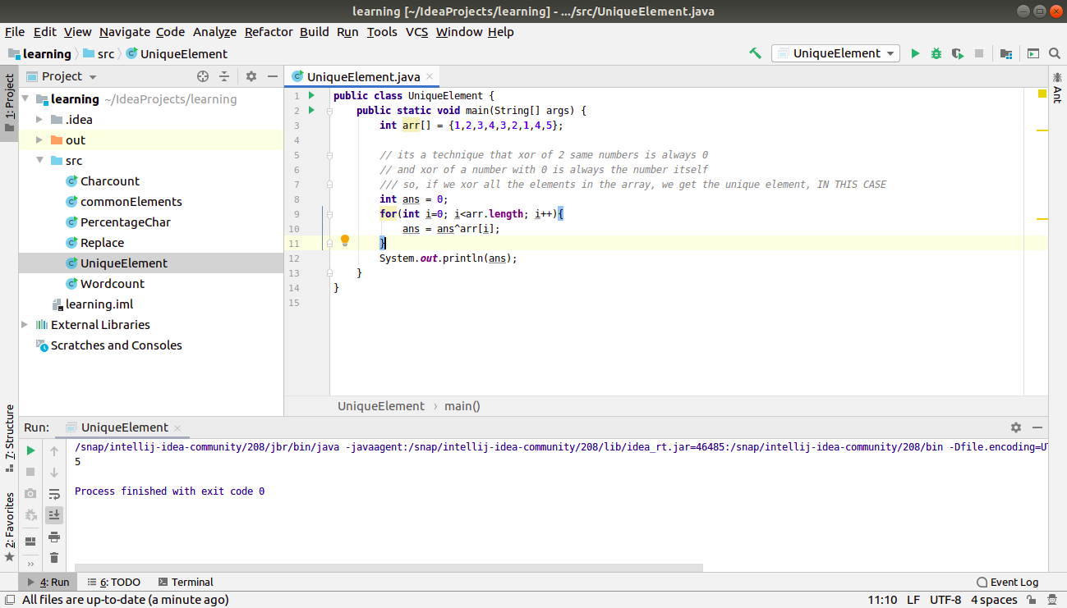

**Q7. Write a program to print your Firstname,LastName & age using static block,static method & static variable respectively.**

**class** Static {

**static int** *age* = 20;

**static**{

System.***out***.println(**"First name - "** + **"Raghav"**);

}

**static void** printLastName(String lastName){

System.***out***.println(**"last name - "** + lastName);

}

}

**public class** staticDemo{

**public static void** main(String[] args) {

System.***out***.println(**"age - "** + Static.*age*);

Static.*printLastName*(**"Gupta"**);

}

}

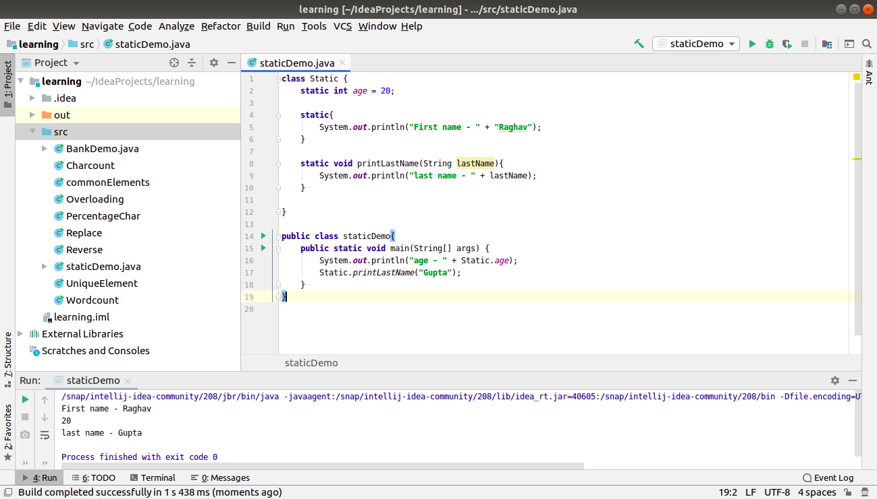

**Q8. Write a program to reverse a string and remove character from index 4 to index 9 from the reversed string using String Buffer**

**public class** Reverse {

**public static void** main(String[] args) {

StringBuffer s = **new** StringBuffer(**"determination"**);

System.***out***.println(**"original string - "** + s);

s.reverse();

System.***out***.println(**"reversed string - "** + s);

s.replace(4, 10, **""**);

System.***out***.println(**"after removing the characters - "** + s);

}

}

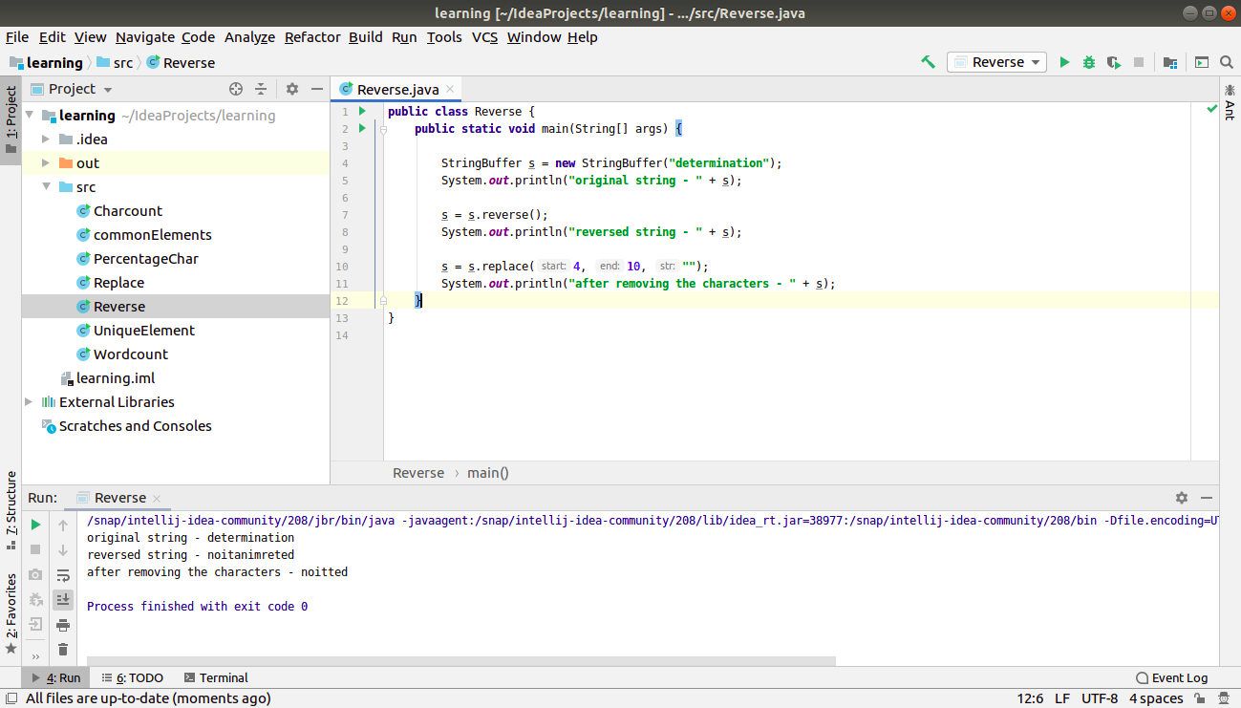

**Q9.Write a program to display values of enums using a constructor & getPrice() method (Example display house & their prices)**

**public class** enumDemo {

**enum** House{

***BUNGLOW***(25000),

***VILLA***(20000),

***MANSION***(15000),

***APARTMENT***(10000);

**private int value**;

House(**int** value){

**this**.**value** = value;

}

**public int** getPrice(){

**return value**;

}

}

**public static void** main(String[] args) {

**for**(House h : House.*values*()){

System.***out***.println(h + **" - price is $"** + h.getPrice());

}

}

}

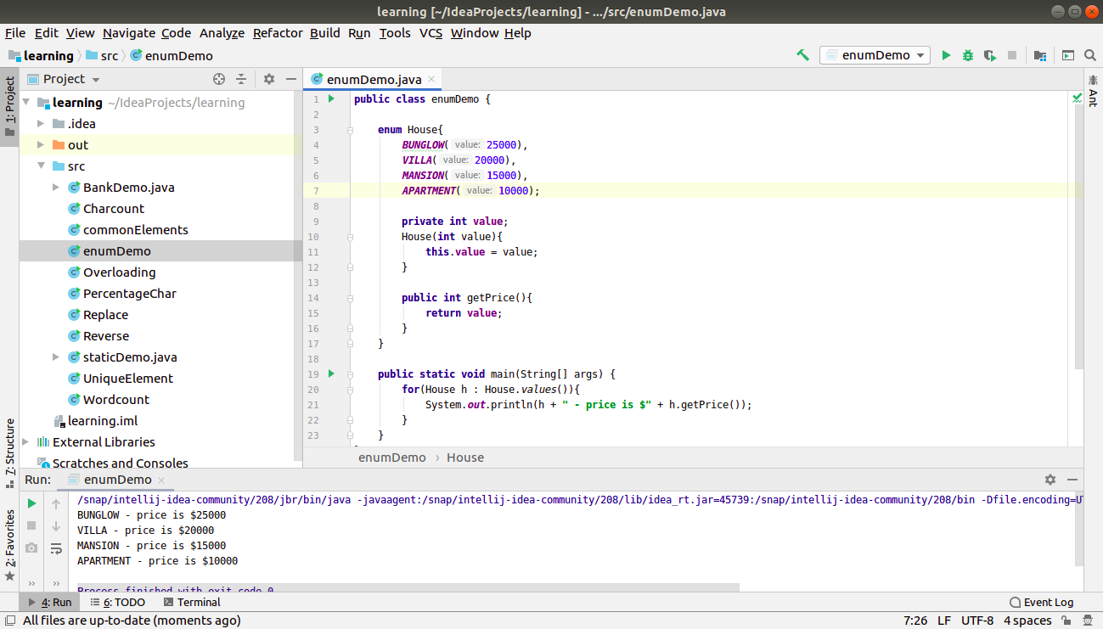

**Q10.Write a single program for following operation using overloading**

**A) Adding 2 integer number**

**B) Adding 2 double**

**C) multiplying 2 float**

**D) multiplying 2 int**

**E) concate 2 string**

**F) Concate 3 String**

**public class** Overloading {

*// overloaded add function*

**int** add(**int** a, **int** b){

**return** a+b;

}

**double** add(**double** a, **double** b){

**return** a+b;

}

*// overloaded mul function*

**int** mul(**int** a, **int** b){

**return** a*b;

}

**float** mul(**float** a, **float** b){

**return** a*b;

}

*// overloaded concat function*

String concat(String a, String b){

**return** a+b;

}

String concat(String a, String b, String c){

**return** a+b+c;

}

**public static void** main(String[] args) {

Overloading o = **new** Overloading();

System.***out***.println(o.add(2,3));

System.***out***.println(o.add(2.5768898,3.7897678));

System.***out***.println(o.mul(2,3));

**float** x=2.6f, y=3.5f;

System.***out***.println(o.mul(x,y));

System.***out***.println(o.concat(**"raghav"**, **"gupta"**));

System.***out***.println(o.concat(**"raghav"**, **" "**, **"gupta"**));

}

}

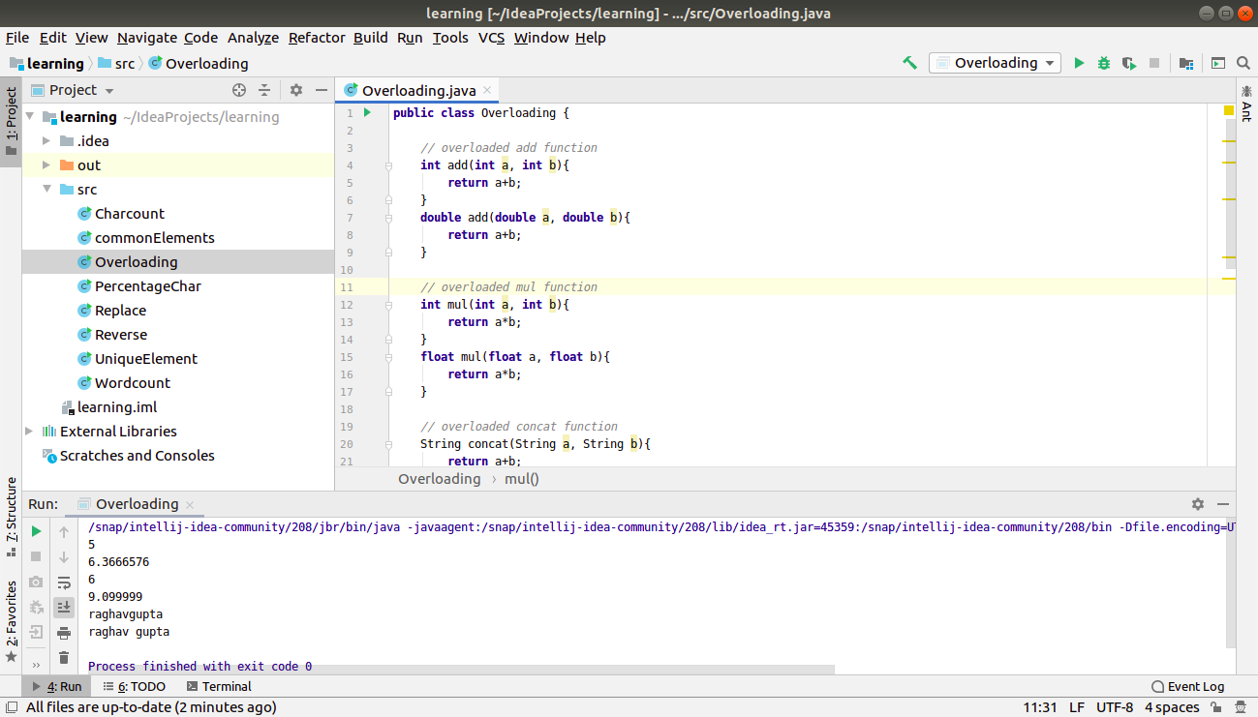

**Q11.Create 3 sub class of bank SBI,BOI,ICICI all 4 should have method called getDetails which provide there specific details like rateofinterest etc,print details of every banks**

**class** Bank {

**private** String **name**;

**private double worth**;

**private int customerCount**;

**private** String **yearOfEstablishmment**;

**public void** getDetails(){

System.***out***.println(**"name - "** + **name**);

System.***out***.println(**"established in - "** + **yearOfEstablishmment**);

System.***out***.println(**"total worth - $"** + **worth**);

System.***out***.println(**"number of customers - "** + **customerCount**);

}

**public void** setDetails(String a, **double** b, **int** c, String d){

**name** = a;

**worth** = b;

**customerCount** = c;

**yearOfEstablishmment** = d;

}

}

**class** BOI **extends** Bank{

**private double interestRate**;

BOI(**double** rate){

**this**.**interestRate** = rate;

}

**public void** getDetails(){

**super**.getDetails();

System.***out***.println(**"interest rate - "** + **interestRate**);

}

}

**class** SBI **extends** Bank{

**private double interestRate**;

SBI(**double** rate){

**this**.**interestRate** = rate;

}

**public void** getDetails(){

**super**.getDetails();

System.***out***.println(**"interest rate - "** + **interestRate**);

}

}

**class** ICICI **extends** Bank{

**private double interestRate**;

ICICI(**double** rate){

**this**.**interestRate** = rate;

}

**public void** getDetails(){

**super**.getDetails();

System.***out***.println(**"interest rate - "** + **interestRate**);

}

}

**public class** BankDemo{

**public static void** main(String[] args) {

SBI s = **new** SBI(7.5);

s.setDetails(**"SBI"**, 29400000, 5600000, **"1901"**);

s.getDetails();

System.***out***.println(**"------------"**);

BOI b = **new** BOI(3.4);

b.setDetails(**"BOI"**,3400000, 5600, **"2001"**);

b.getDetails();

System.***out***.println(**"------------"**);

ICICI i = **new** ICICI(6.3);

i.setDetails(**"ICICI"**, 99000000, 900, **"2010"**);

i.getDetails();

}

}

